Sentiment Analysis On Tweets Using Afinn Dictionary

Register the downloaded jars in pig

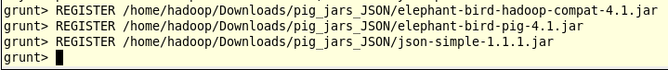

Load the tweets using JsonLoader

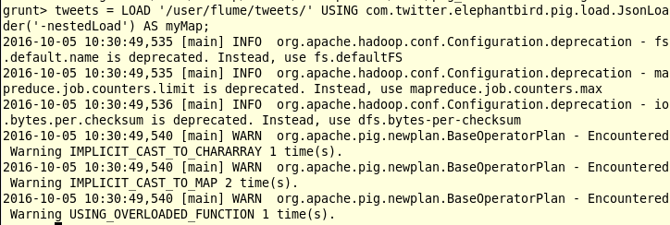

Extract the id and the tweet text

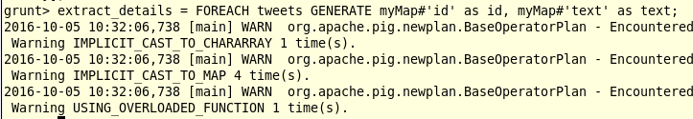

Extract the words from the text using the TOKENIZE key word

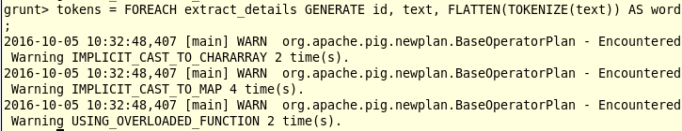

Screen shot of the text got divided into words

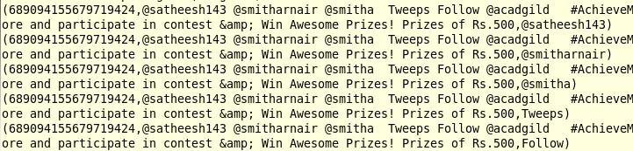

Load the AFINN dictionary

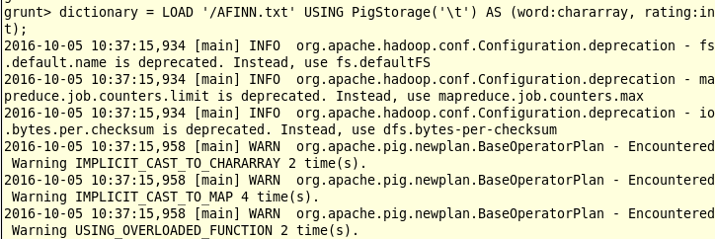

Contents of the AFINN dictionary

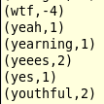

Map side join by joining the tokens statement and the dictionary contents

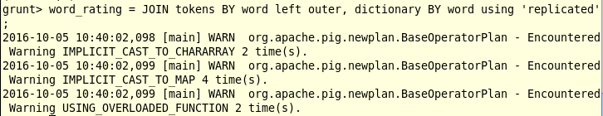

Schema of the word_rating

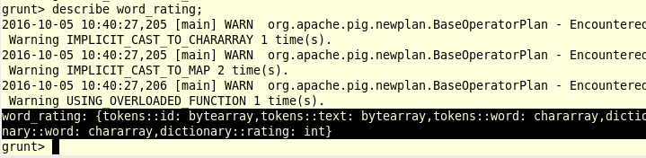

Extract the id, tweet text and word rating

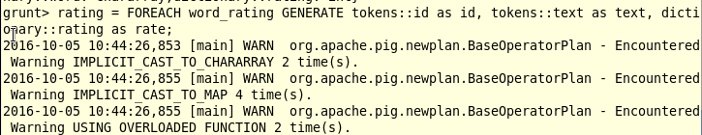

Schema of the relation rating

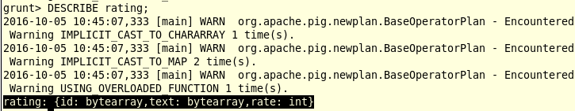

Group the rating of all the words

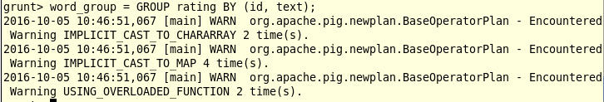

Average operation on the rating of the words per each tweet

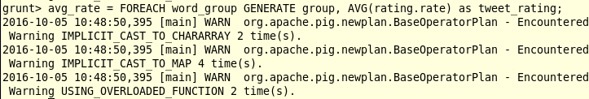

Filter the positive tweets

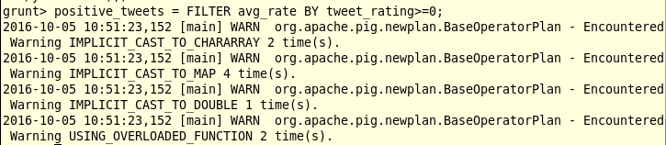

Positive tweets and its rating in the below screen shot

